# Risk calculation Algorithm

First draft by Takis Stathatos

The PTS system needs to calculate risk for passengers and flights.

### Risk Score

1. Location of passenger, if passenger is from a country listed as a country of risk by then the passenger score is incremented by 2.
2. If the passenger has a general criminal conviction the score is incremented by 2
3. If the passenger has a criminal conviction for smuggling the score is incremented by 5
4. If the passenger has a criminal conviction for terrorist related activity score is incremented by 10
5. If the passenger is on a terrorism watch list the score is incremented by 10
6. If a flight starts from a country of risk, score 4
7. If a flight’s destination to a country of risk, score 4

### Risk RAG

Green Score = 0

Amber Score = 2 – 6

Red Score > 7

### Passenger risk;

Is calculated by adding Risk Score items 1 – 5.

### Flight risk;

is calculated by adding risk of all passengers and Risk Score items 6 & 7.

## Database fields

[Rob please just use this a draft idea to design your database, the score can either be done in the database or in the php code]

Database fields to be added:

1. Add Country to the Passenger details PASSENGER_DETAIL.COUNTRY this will make the country check easier
2. Add flight risk FLIGHT_DETAIL.FLIGHT_RISK
3. Add two new tables;

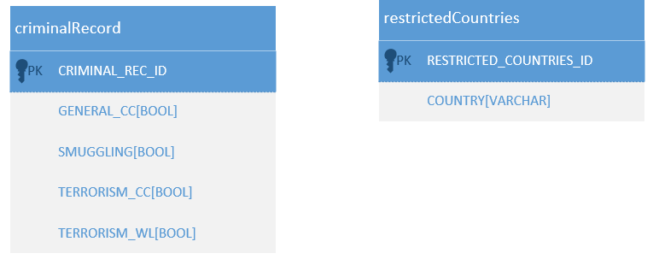

## Code Design

1. As we’re not using a front end to add data, the criminal record data can be put straight into the database. I envisaged it as a separate table but it could be an extension of the passenger details table. Each field is just true or false.
2. The country field on the passenger details is checked against the Countries of Risk table
3. The individual passenger risk can either be calculated in the database and the score added to PASSENGER_DETAIL.RISK_SCORE or it can be done in php and the same field by updated for each passenger. The second approach would mean that the database only gets updated once a passenger has been selected so db score would be better if possible.  
     
   Code something like this:

#### For passengers

//Initialise passenger risk to 0  
RISK_SCORE = 0

//Check and increment risk against convictions

IF (GENERAL_CC) RISK_SCORE+=2

IF (SMUGGLING) RISK_SCORE+=2

IF (TERRORISM_CC) RISK_SCORE+=10

IF (TERRORISM_WL) RISK_SCORE+=10

//Check if the passenger’s country is on restricted list

IF(PASSENGER_DETAIL.COUNTRY EXISTS IN restrictedCountries) RISK_SCORE+=5

//Increment passenger risk field if needed

PASSENGER_DETAIL.RISK_SCORE = RISK_SCORE

#### For the flights;

//initialise the flight risk to zero

FLIGHT_DETAIL.FLIGHT_RISK = 0

//Get all passengers on flight and add their score to the FLIGHT_RISK

FOREACH PASSENGER WITH FLIGHT ID = CURRENT FLIGHT

FLIGHT_DETAIL.FLIGHT_RISK += PASSENGER_DETAIL.RISK_SCORE

//Check the start and destination are not on the list of countries at risk if they are

// add the risk to the flight score.

IF(FLIGHT_DETAIL.ORIGIN EXISTS IN restrictedCountries) RISK_SCORE+=2

IF(FLIGHT_DETAIL.DESTINATION EXISTS IN restrictedCountries) RISK_SCORE+=2

//Update the flight risk score in the db (if needed)

FLIGHT_DETAIL.FLIGHT_RISK = FLIGHT_RISK

# Appendix 1 List of countries with travel warning

Source <https://travel.state.gov/content/travel/en/traveladvisories/traveladvisories.html.html>

Honduras Travel Alert

Pakistan

Lebanon

Worldwide Caution

Togo

Sudan

Syria

Democratic Republic of the Congo

Mauritania

Cameroon

Cuba

Haiti

Eritrea

Kenya

Ethiopia

Bangladesh

Mexico

Iran

North Korea

Somalia

Jordan

Republic of South Sudan

Egypt

Philippines

Mali

Burundi

Algeria

Colombia

Iraq

Burkina Faso

Chad

Central African Republic

Tunisia

Israel, The West Bank and Gaza

Saudi Arabia

El Salvador

Libya

Honduras

Afghanistan